Fired Heater MPC Simulation

In this exercise we explore the dynamic behavior of a fired heater controlled by a Model Predictive Control (MPC) application. The fired heater simulation that we use here is a simplified representation of the type of heater found at the front end of a petroleum refinery [1], which has the job of vaporizing the feed oil so that it can be separated by fractionation. Because of its location at the front end of the refinery, small increases in the oil feedrate to the heater can have enormous economic benefits. In a typical MPC application of this type, a 0.5% increase in the heater feedrate can result in more than $1M/year in economic benefits.

The Fired Heater Control Problem

Consider the simplified fired heater in Figure 1. A feed stream of cold oil splits into two tubes that pass over burners fired by fuel gas. The tubes then recombine to produce a heated oil stream that continues on for further processing. The circles indicate measurements and flow controllers most relevant to heater operation. These fall into three basic groups. The green group, known as Manipulated Variables (MVs), correspond to variables that the MPC algorithm (or a human operator) may adjust to achieve the desired control objectives. These are the setpoint of the tube 1 flow controller FC1, the setpoint of the tube 2 flow controller FC2, and the setpoint of the fuel gas flow controller FG. The red group, known as Disturbance Variables (DVs), are measurements that provide feedforward information for the control algorithm. Here the DVs are the two tube oil inlet temperatures TI1 and TI2. The blue group, known as Controlled Variables (CVs), are measurements of the quantities that must be controlled. This includes the external skin temperature of each tube TS1 and TS2, the oil outlet temperature for each tube TO1 and TO2, and the combined oil temperature TO and flowrate FO exiting the heater.

The fired heater MPC design specification is presented in the Table 1, which lists the key process variables and corresponding specifications. A vital aspect of the MPC design is the requirement to prioritize the CVs. This is done to make sure that the control focuses first on the most important goals, and then tries to achieve remaining goals in a prioritized order only if enough degrees of freedom are available. The highest priority specifications involve constraints associated with safety. Lower-level priorities typically include meeting desired product specifications and saving energy. For the fired heater example, the top priority is to make sure that tube skin temperatures TS1 and TS2 do not exceed a maximum safety limit. The second and third priorities are to achieve the desired combined oil outlet temperature and flowrate. A fourth priority, when conditions allow, is to balance the tube outlet temperatures TO1 and TO2 in order to maximize heat transfer efficiency, and to prevent one of the tubes from getting too hot and coking up. For this purpose, we define a delta temperature variable DT as the difference between the tube 1 and 2 oil outlet temperatures. Note that maximum, minimum, and rate of change limits are provided for each MV. These do not have an associated priority because they can always be enforced.
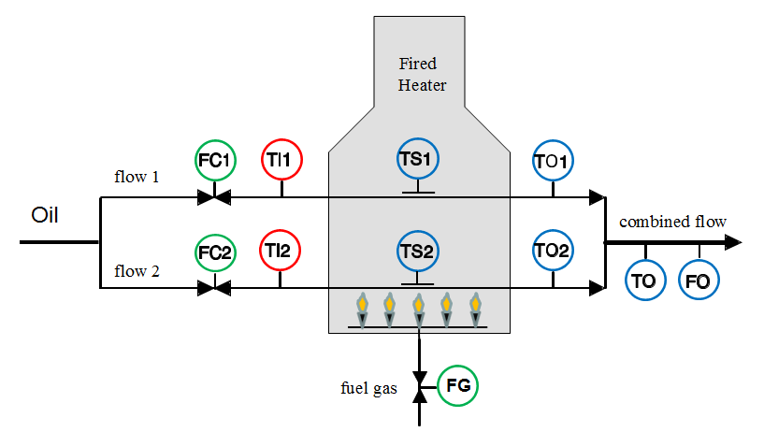
Figure 1: Simplified fired heater warms up an oil stream by passing it over a set of burners fired by fuel gas. Manipulated Variables (MVs), Disturbance Variables (DVs), and Controlled Variables (CVs) are highlighted.

Table 1: Fired heater MPC design specification
Variable | Description (Units) | Type | Priority | Specification
TS1 | Tube 1 skin temperature (F) | CV | 1 | Max. limit
TS2 | Tube 2 skin temperature (F) | CV | 1 | Max. limit
TO | Combined outlet temperature (F) | CV | 2 | Setpoint
FO | Combined outlet flowrate (BPH) | CV | 3 | Setpoint
TO1 | Tube 1 outlet temperature (F) | - | - | -
TO2 | Tube 2 outlet temperature (F) | - | - | -
DT | Delta temperature TO1 – TO2 (F) | CV | 4 | Setpoint (0)
FC1.SP | Flow controller tube 1 setpoint (BPH) | MV | - | Max/Min/ROC
FC2.SP | Flow controller tube 2 setpoint (BPH) | MV | - | Max/Min/ROC
FG.SP | Fuel gas flow controller setpoint (MSCFH) | MV | - | Max/Min/ROC
TI1 | Inlet temperature tube 1 (F) | DV | - | -
TI2 | Inlet temperature tube 2 (F) | DV | - | -

After laying out the MPC design specification the next step is to develop a mathematical model that predicts the effects of MV and DV changes on the CVs. Figure 2 illustrates how the model can be viewed in terms of process inputs (MVs and DVs) and process outputs (CVs). Such a model is often referred to as Multiple Input/Multiple Output (MIMO). The vast majority of industrial MPC applications rely on a linear empirical MIMO model developed from process step response data.
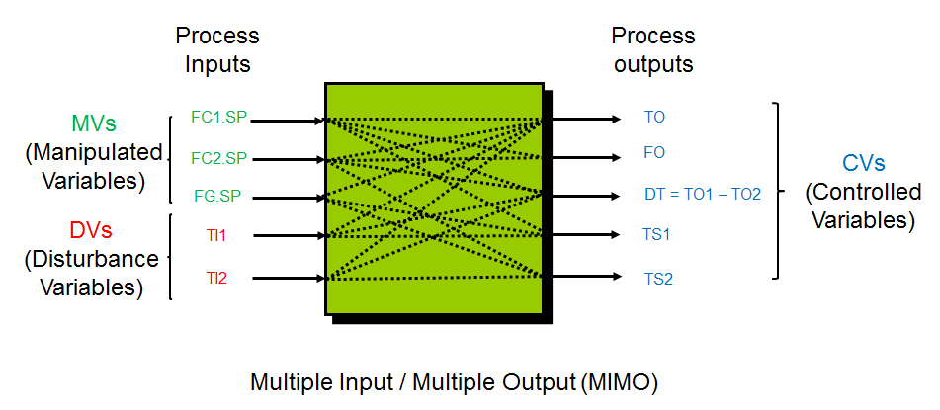
Figure 2: Fired heater process inputs and output

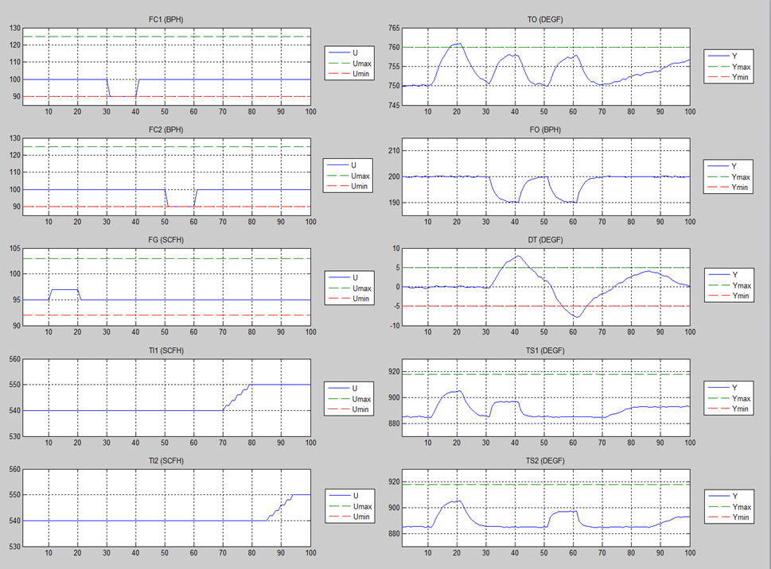
Figure 3: Fired heater step test (note that the correct engineering units for FG, TI1, and TI2 are MSCFH, F, and F)

Figure 3 illustrates a process step test for the fired heater. The process inputs are plotted in the left column, and the process outputs are shown in the right column. Time in minutes is plotted on the horizontal axis. At the 10-minute mark we increase the fuel gas flow FG from 95 to 97 MSCFH and then return it to 95 MSCFH 10 minutes later. In the right column the effects of this pulse on the CVs can be seen. The combined oil outlet temperature TO increases by a little more than 10 F and then comes back down again. The combined oil flowrate FO and the tube outlet temperature difference DT remain unchanged, while both tube skin temperatures TS1 and TS2 rise and then fall. With this information we can derive all of the models related to fuel gas flow FG. In a similar way we make changes to the two pass flow controllers FC1 and FC2 and observe the responses of the CVs. Since we cannot directly change the tube inlet temperature DVs, we must either search historical data or, as shown here, we assume that we are able to make changes to upstream equipment to increase the oil inlet temperature. In the ideal case shown here we are able to make significant, independent changes to each process input, and we collect significant, essentially noise-free data that shows the effects on each output.

The step test data are then passed into appropriate modeling software to develop a dynamic model. The data must first be edited to remove effects that we do not want to include in the model, such as might happen during a process upset. The data are then typically band-pass filtered to remove the steady-state information and any high-frequency noise. A subspace identification method [4] can then be used to identify a linear state-space model. The step response of the resulting model is illustrated in Figure 4. In this representation the process inputs appear as columns, and the process outputs appear as rows. Each column shows how the outputs would respond to a pure unit step change increase in the given input. For example, the middle column shows how the CVs respond to a unit increase in the fuel gas flowrate FG. The final value in each cell is known as the process gain. The first cell in the middle column shows that the combined outlet temperature TO increases by about 6 F, so the gain for this model is 6 F/MSCFH. The second and third cells show no changes for the combined outlet flow FO and the tub outlet delta temperature DT. The last two cells show that the tube skin temperatures both increase by about 10 F. Of course, these responses match the data that was recorded during the step test.

Figure 5 shows how the fired heater MPC application is configured. The application runs at a one-minute frequency in a dedicated PC, communicating with the process instrumentation through a standard protocol such as OPC. Every minute it reads in current values of the CVs and DVs and then sends an adjustment out to the MVs.

Results from a closed-loop test of the fired heater MPC are shown in Figure 6. Again, the process inputs are shown in the left column and process outputs appear in the right column. The first change occurs at the ten-minute mark, when the operator increases the TO setpoint by 5 F. The control responds by sharply increasing FG from 95 to over 97 MSCFH, and then bringing it down to settle around 96 MSCFH. This has the effect of increasing TO quickly up to the new setpoint of 755 F. There is, of course, no change in FO or DT, but TS1 and TS2 both increase as expected.

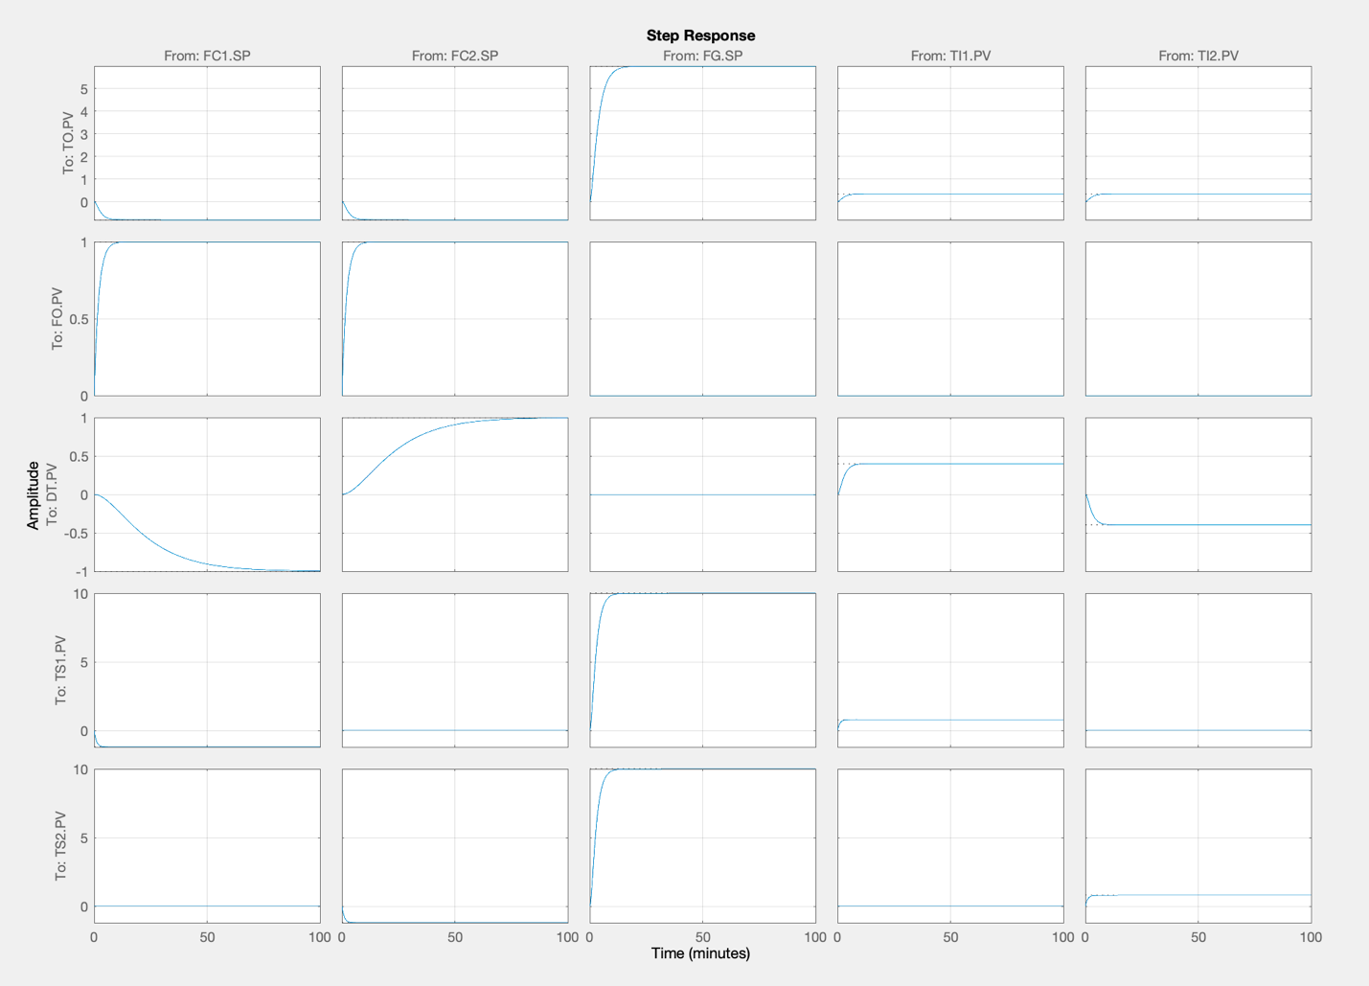
Figure 4: Fired heater step response model

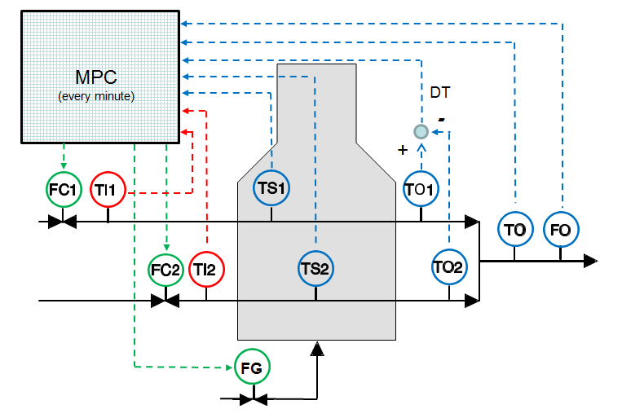
Figure 5: Fired heater MPC configuration

The next change comes at the 30-minute mark when the operator asks to increase FO by 20 BPH without changing TO or DT. The MPC accomplishes this by increasing both FC1 and FC2, while also carefully increasing FG in such a way that TO remains constant.

Having successfully added 20 BPH of feed the operator tries to do the same thing at the 50-minute mark. This time, however, the MPC determines right away that it will not be able to reach the new setpoint of 240 BPH. The steady-state target for FO (green line) only goes up to around 235 BPH. MPC stops short on the FO because it predicts that it will run out of room on the tube skin temperatures TS1 and TS2. We have configured these limits as the top priority control specifications, so the MPC will not allow these limits to be violated. This places a limit on the available heat input, and we have said that the next highest priority is to maintain the heater outlet temperature TO, so the control gives up on the FO setpoint. This illustrates how priorities are used to resolve conflicting control objectives in a MPC application.

At the 70-minute mark we can see that the oil entering the first tube begins to warm up. This means that less energy will be required to meet the TO setpoint so the control is able to push a little more feed into the heater. It increases FC1 and FC2 in order to keep DT as close to zero as possible. At 85 minutes the other tube inlet temperature increases enough to allow the FO setpoint to be reached.

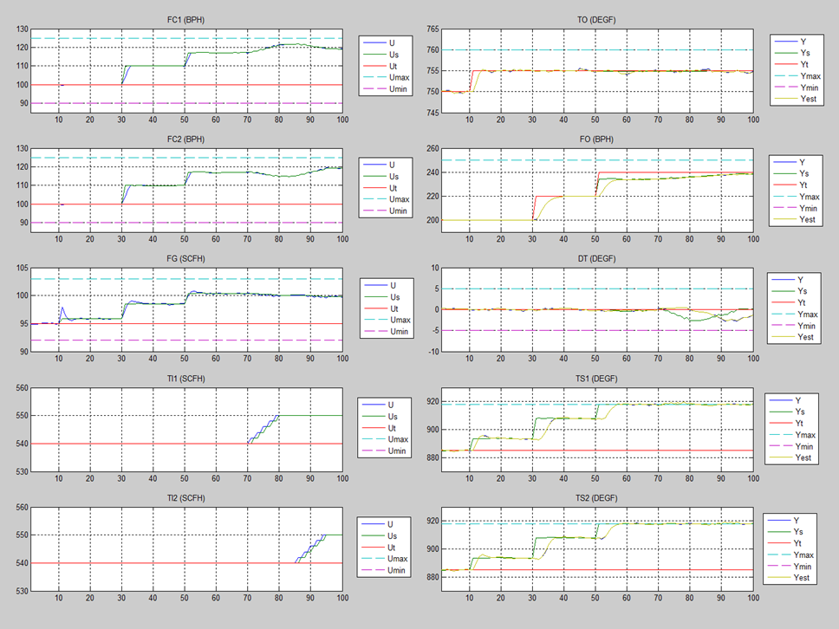
Figure 6: Fired heater MPC closed-loop test.
Installing the simulation code

The plan now is for you to install the simulation code and test-drive the fired heater MPC controller for yourself. The simulation code is designed to run on Matlab or Octave, and makes use of the Matlab Control Toolbox as well as two third-party software packages: MPCTOOLS [2], and CasADi [3].

To install the simulation code, first unzip the files to a convenient location. CasADi files are provided for both mac and windows installations, so the next step is to delete the casadi folder that you do not need. Finally, you need to add the fired_heater_simulation folder and its subfolders to the Matlab path using the “Set Path” button and the “Add with Subfolders” option.

If you are using a Mac computer, you may need to open each .dylib file in casadi by right clicking on it, to let the operating system know that you think the files are safe. You may also need to right click and open casadiMEX.mexmaci64.

Running the simulation example

To start the simulation, run the file heater_mpcsim.m:

>> heater_mpcsim

The following simulation window should appear on your screen:

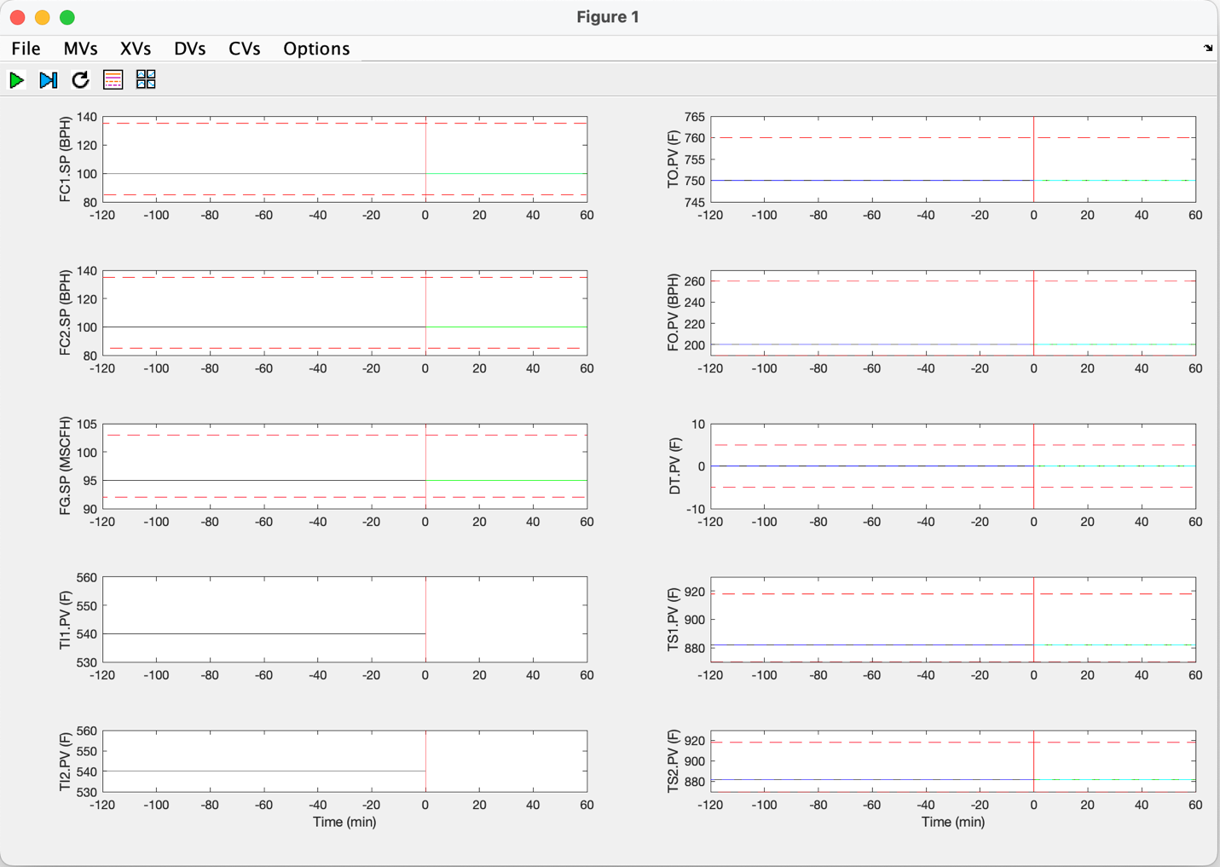

The simulation window shows two columns of plots. The fired heater process inputs are plotted in the left-hand column, and the process outputs are plotted in the right-hand column.

The first three process inputs in the left-hand column are the Manipulated Variable (MVs):
- FC1.SP – pass 1 flow controller setpoint (BPH)
- FC2.SP – pass 2 flow controller setpoint (BPH)
- FG.SP – fuel gas flow controller setpoint (MSCFH)

The last two process inputs in the left-hand column are the Disturbance Variables (DVs):
- TI1.PV – pass 1 inlet temperature (F)
- TI2.PV – pass 2 inlet temperature (F)

The process outputs plotted on the right-hand side are the Controlled Variables (CVs):
- TO.PV – combined outlet temperature (F)
- FO.PV – combined outlet flow (BPH)
- DT.PV – pass outlet temperature difference (F)
- TS1.PV – pass 1 tubeskin temperature (F)
- TS2.PV – pass 2 tubeskin temperature (F)

Within each plot is a vertical red line that separates past measurements on the left from future predictions on the right. Two hours of past measurements are plotted on the left, and future predictions for the next hour are plotted on the right. Dashed red lines at the top and bottom of each plot represent maximum and minimum limits.

The simulation is controlled using the buttons and menus that appear at the top left of the simulation window. The buttons are used to start/stop the simulation, turn the control on and off, add legends to the plots, and resize the plots:

Run button - toggles the simulation on/off

Step button - runs the simulation for one time step

Control button - toggles the controller on/off

Legend button - toggles the plot legends on/off

Rescale button - rescales the plots

The menus for the MVs, DVs, and CVs allow you to change variable values, setpoints, and controller tuning. The Options menu allows you to set the measurement noise level, change the estimator tuning, and choose which disturbance model will be used to estimate unmeasured disturbances.

Open-loop (control off) experiments

As a first experiment with the simulator, use the MVs menu to increase the FG Value from 95 to 96 MSCFH. Press the Run button and you should see the FG.SP increase from 95 to 96 MSCFH, and the corresponding dynamic response of TO.PV, TS1.PV, and TS2.PV. Press the Run button again to stop the simulation. You should see something like this:

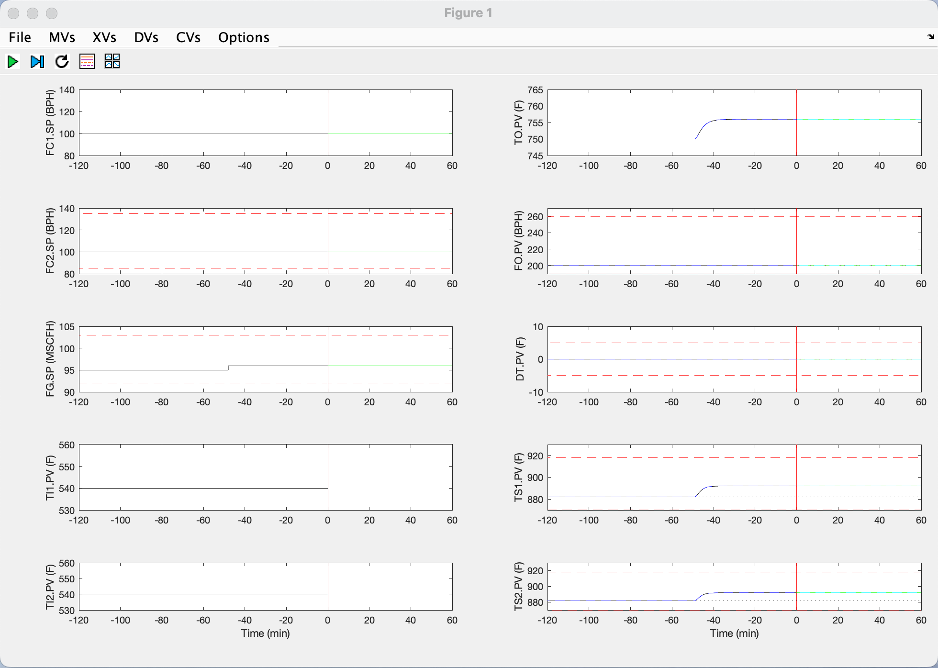

The increase in fuel gas flow has warmed the heater up, so the combined outlet temperature has increased, along with the pass 1 and 2 tubeskin temperatures.

Next use the MVs menu to increase FC1 from 100 to 105 BPH. Increasing the flow through pass 1 will cool off the tubeskin temperature of that pass (TS1.PV) and will increase the total flow through the heater (FO.PV). This will also decrease the combined outlet temperature (TO.PV). The first pass becomes cooler than the second pass so the temperature difference between them (DT.PV) goes negative:

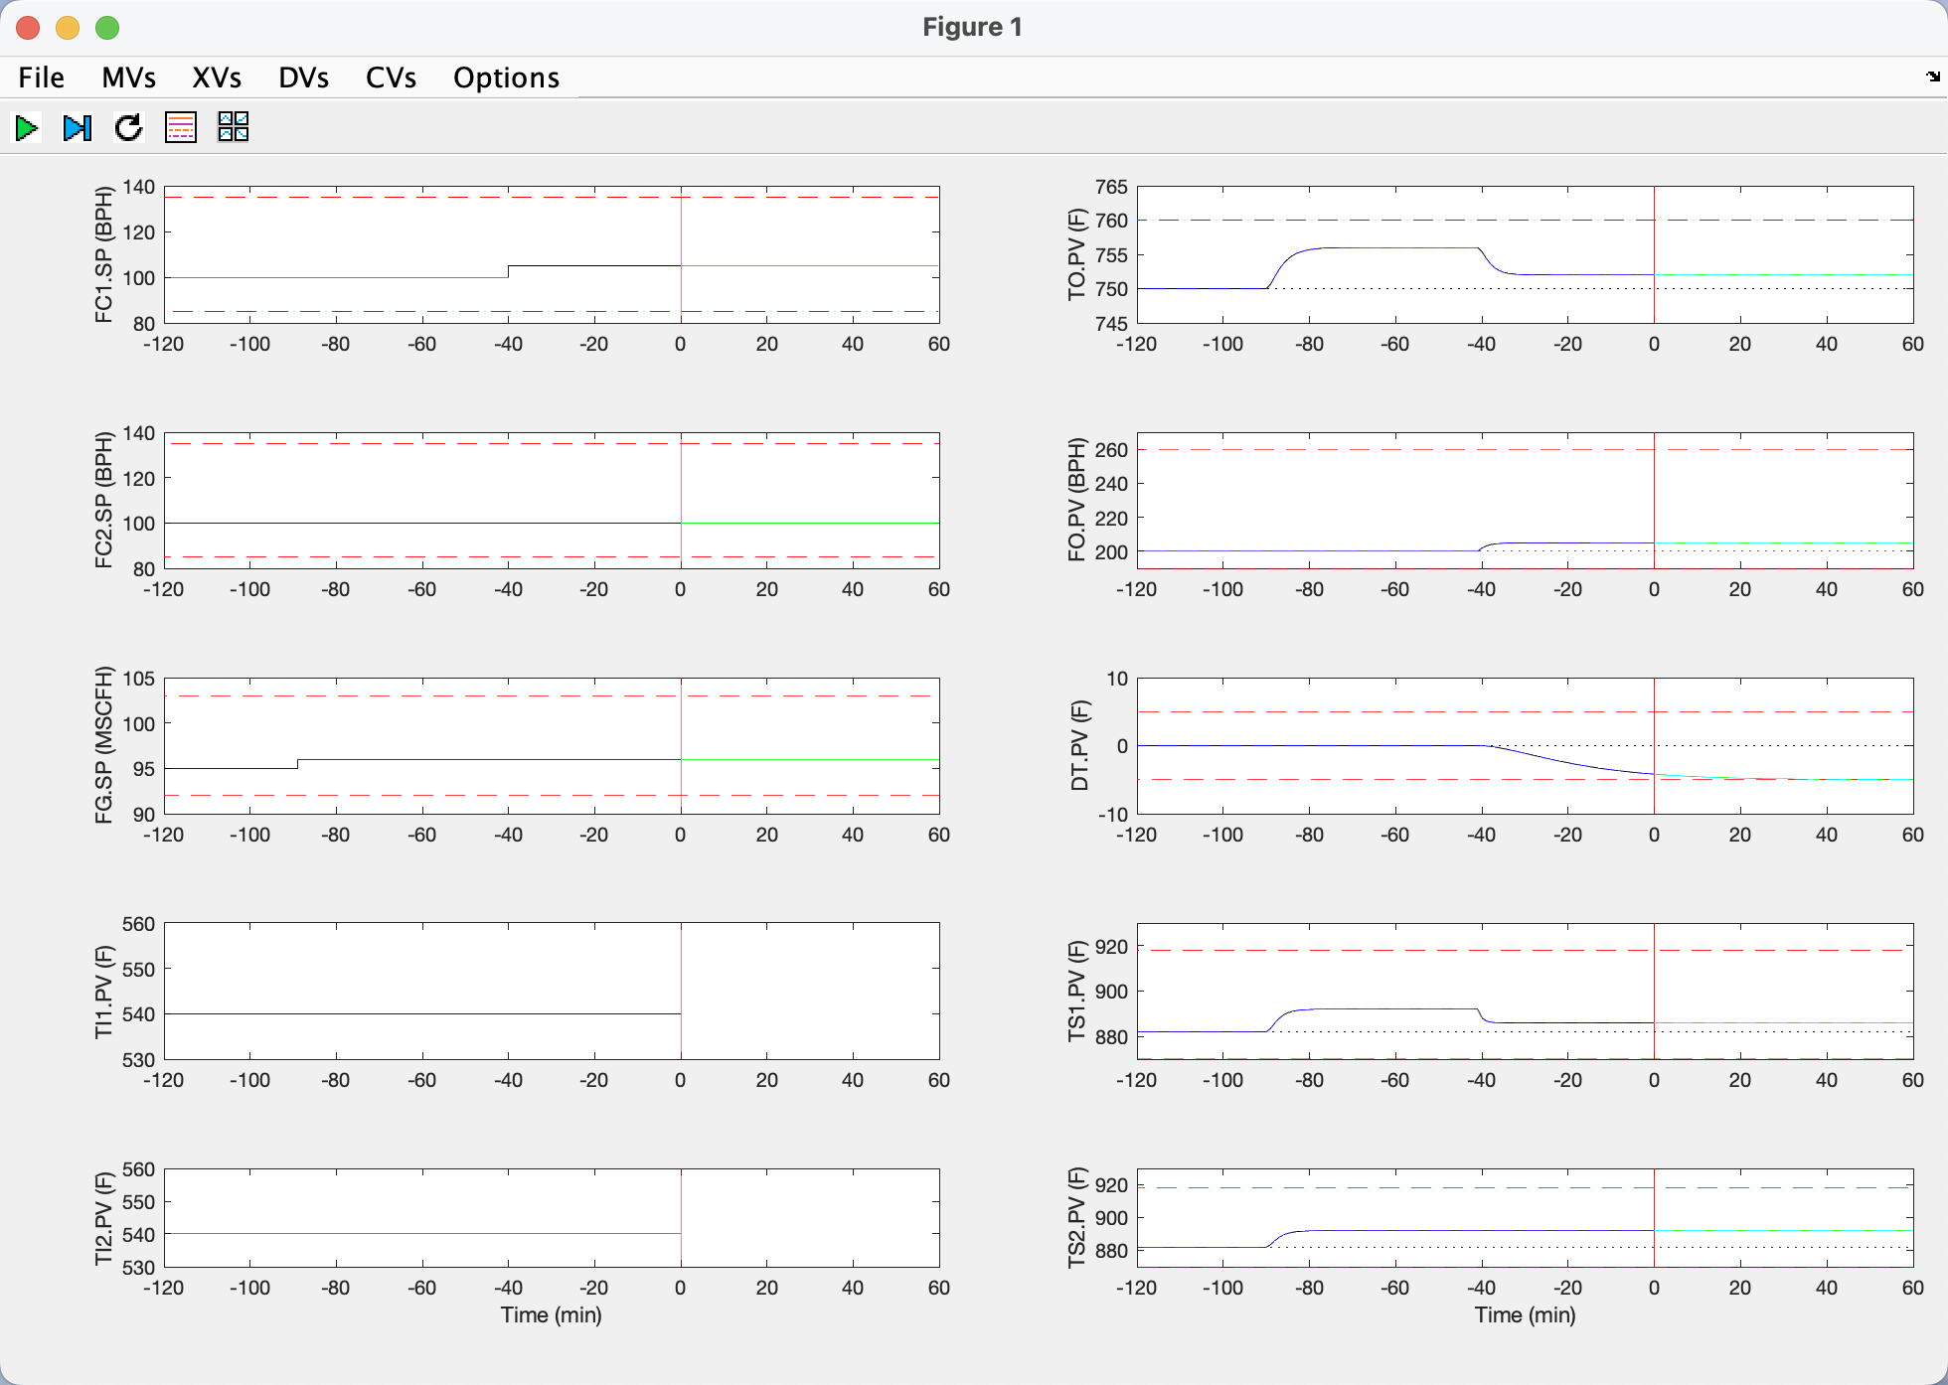

Now increase the pass 2 flow from 100 to 105 BPH and you should see the combined outlet temperature TO.PV decrease, the combined flow FO.PV increase, the pass temperature difference DT.PV come back to zero, and the pass 2 tubeskin temperature TS2.PV decrease:

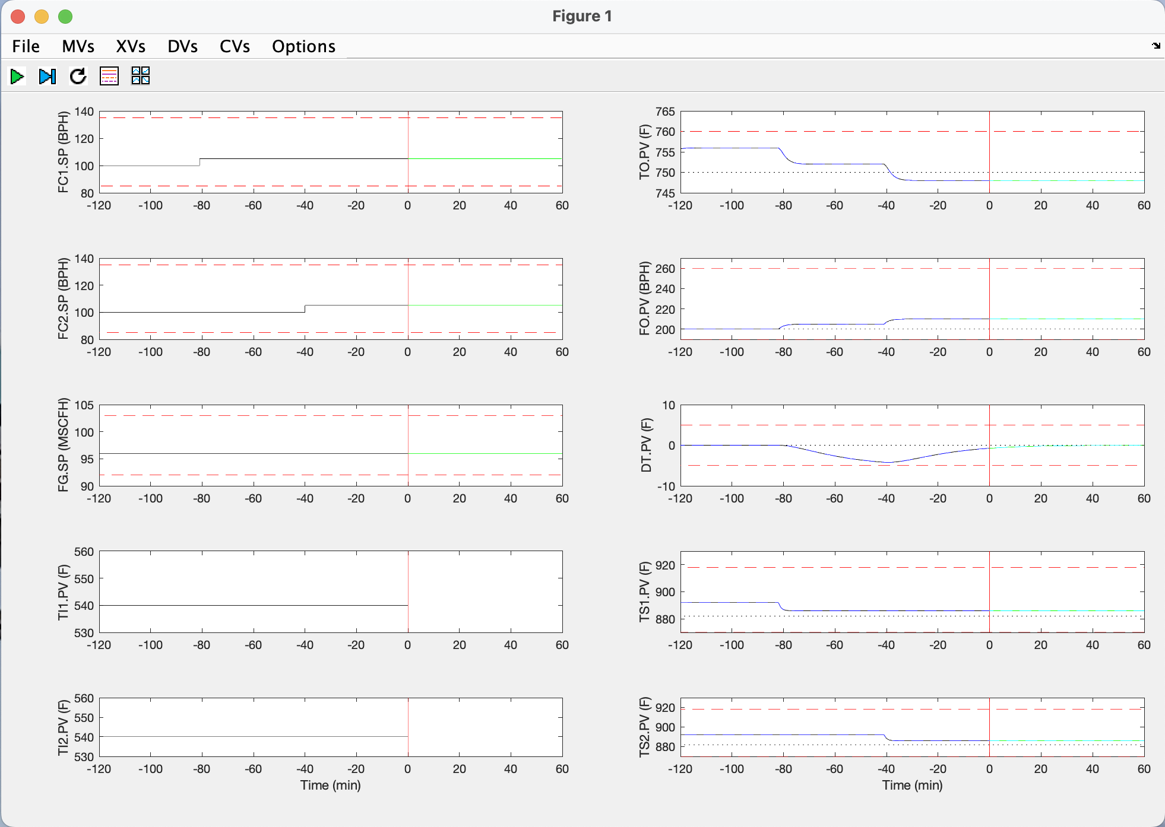

Now return the three MV variables back to their initial values. Set FC1 and FC2 to 100 BPH, and FG to 95 MSCFH. This will cause the CVs to return to their original values:

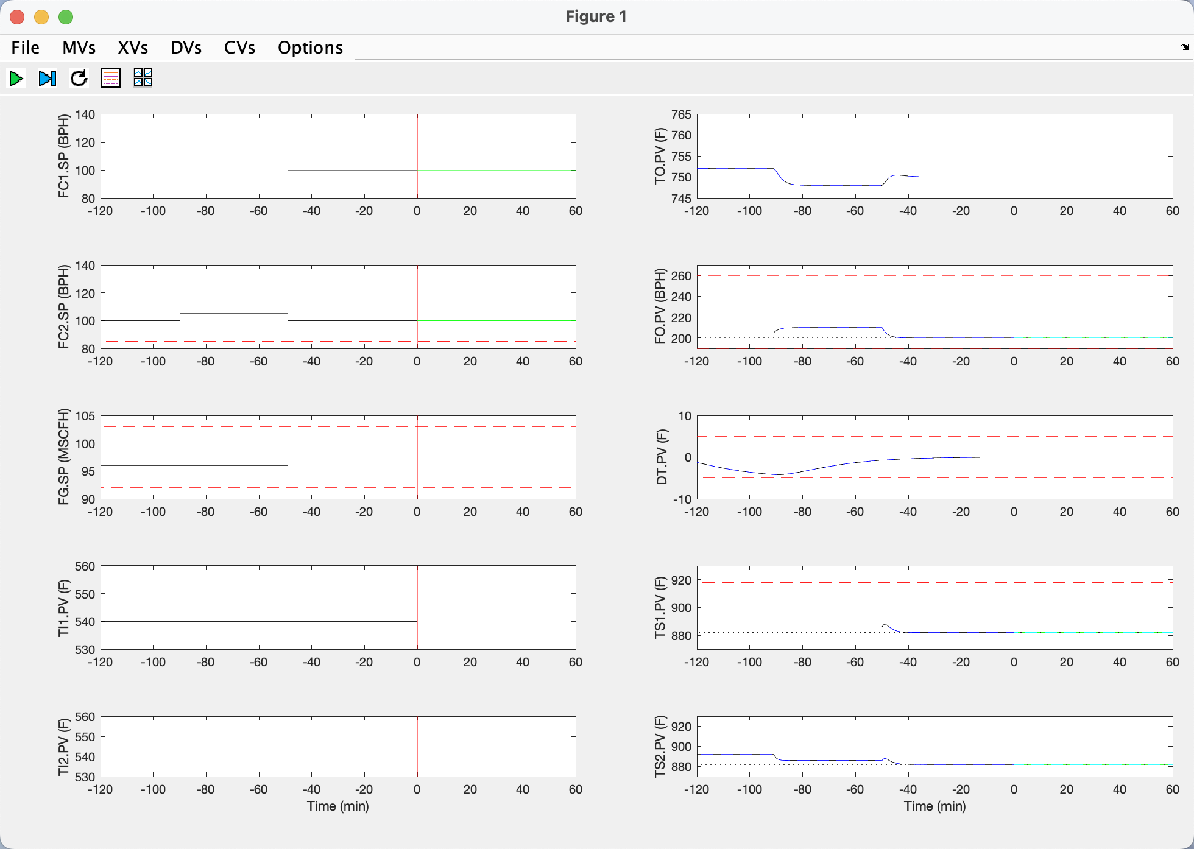

Closed-loop (control on) experiments

Use the CV menu to change the TO Setpoint from 750 to 755 F. Click the Control button and then click the Run button. You should see the control make adjustments to the three MVs to take the TO up to its new setpoint of 755 F. This is accomplished mainly by adjusting the fuel gas flow, although the pass flows are also temporarily decreased in order to help speed up the TO change:

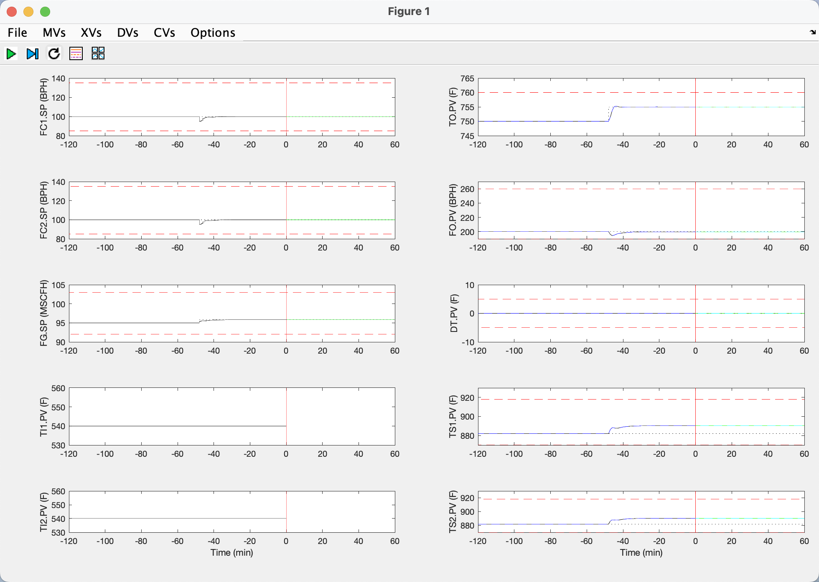

Now change the FO setpoint from 200 to 220 BPH. The control accomplishes this FO setpoint change by increasing the pass flows FC1 and FC2, while simultaneously increasing the fuel gas FG so that that TO stays at its setpoint. FC1 and FC2 are increased in exactly the same way so as to keep the pass temperature difference DT at its setpoint of zero:

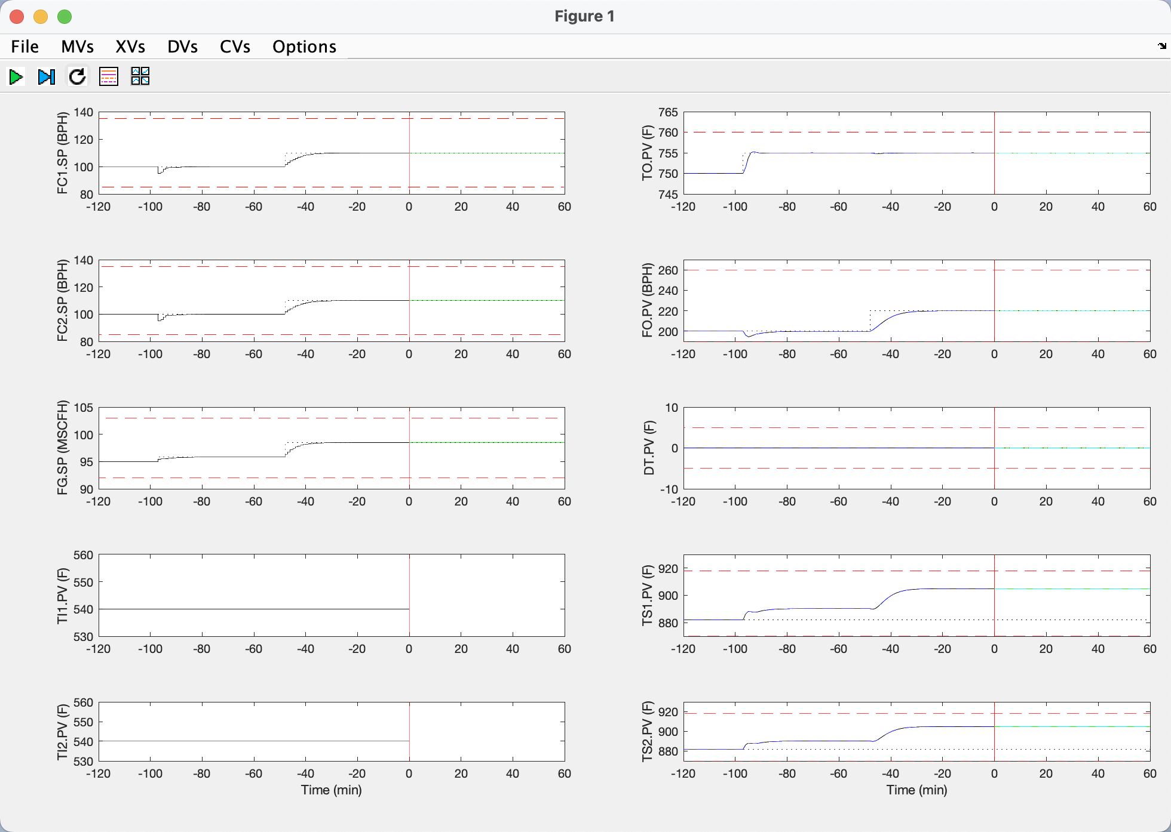

Now change the FO setpoint from 220 to 250 BPH. Notice that the control is not able to bring FO all the way up to its new setpoint since this would cause the tubeskin temperatures TS1 and TS2 to exceed their maximum limits. The control has been configured to respect the tubeskin temperature limits as its top priority. The next priority is to hold TO at its setpoint, followed by holding FO at its setpoint, with holding DT at its setpoint as the lowest priority.

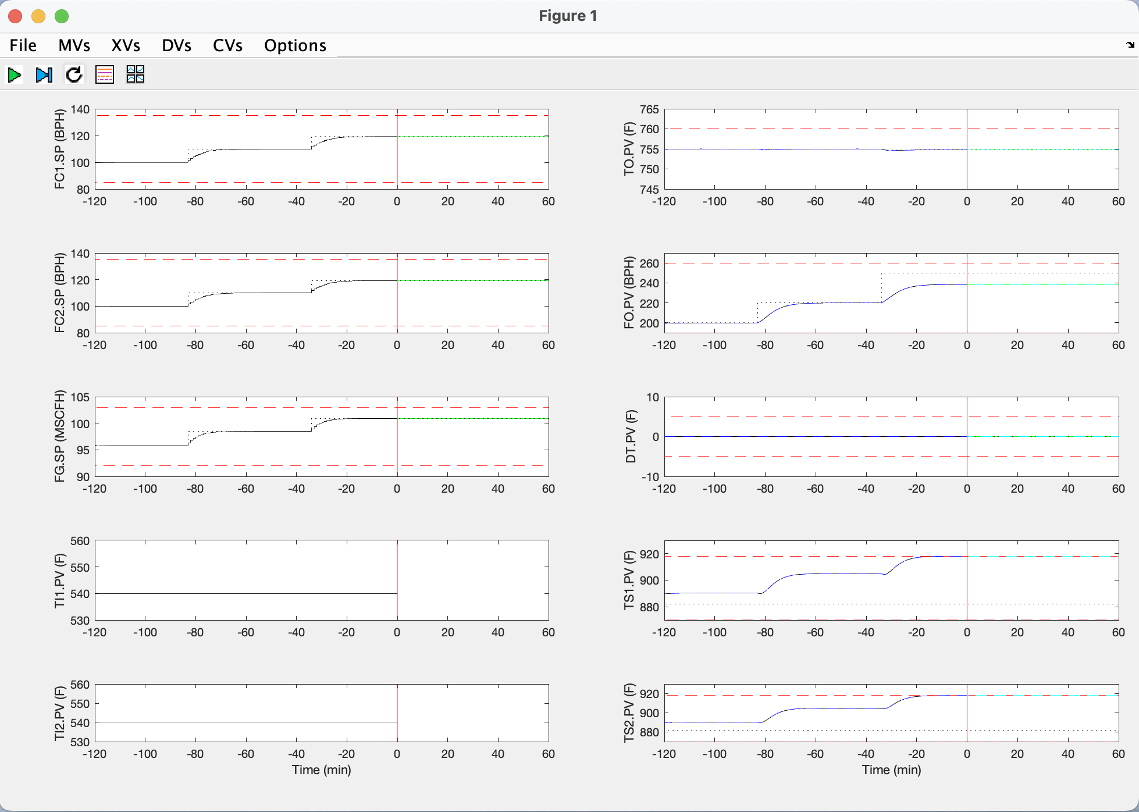

Now decrease the TO setpoint from 755 to 750 F. Notice that this allows the control to bring FO up to its setpoint while still respecting the tubeskin temperature limits.

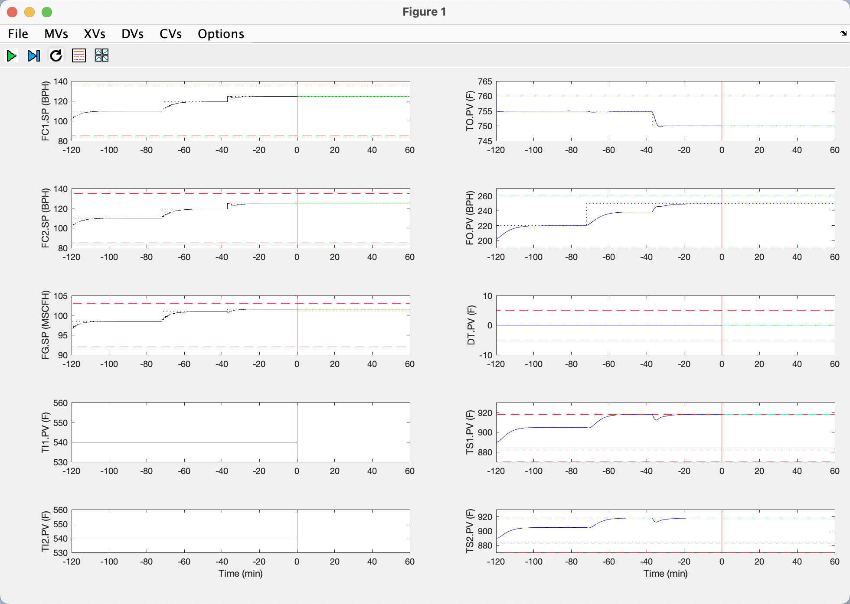

Now change the FO setpoint back to 200 BPH. This returns the simulation back to its initial condition:

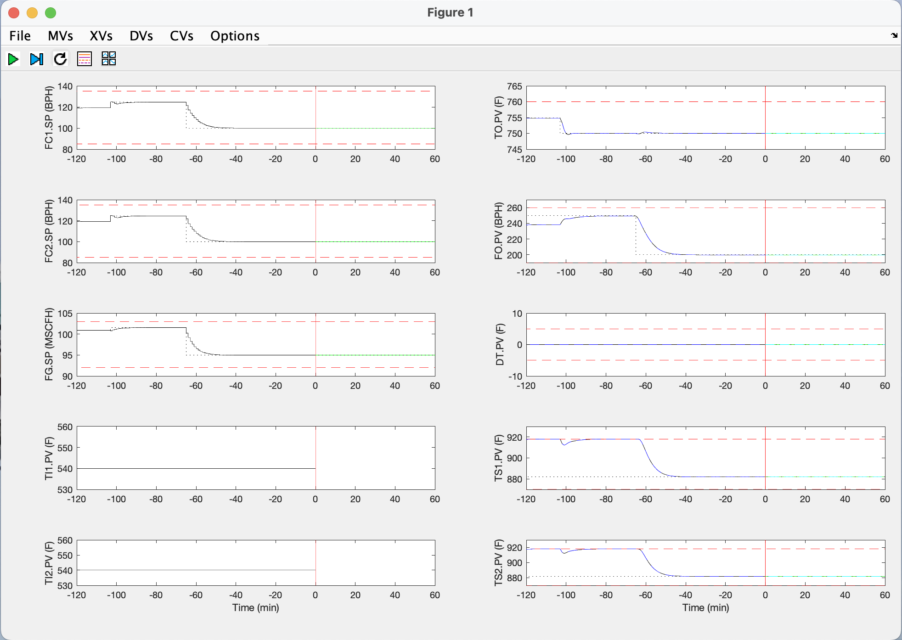

Additional suggested experiments

From here many additional experiments are possible:
- Test how well MPC does feedforward control by adjusting the inlet temperatures TI1 and/or TI2
- Load up the heater again until the tubeskin constraints are active and experiment with other ways to relieve the constraints
- Adjust the controller tuning to speed up or slow down the control response
- Conduct open-loop step-test experiments, collect the data, and identify your own step response model. Note that the data from each run are saved in file heaterData.mat.

References

[1] J.H. Gary, G.E. Handwerk, M.J. Kaiser, “Petroleum Refining, Technology and Economics”, Fifth Edition, CRC Press, (2007).
[2] M.J. Risbeck, J.B. Rawlings, “MPCTools: Nonlinear model predictive control tools for CasADi (Octave interface)”, https://bitbucket.org/rawlings-group/octave-mpctools, (2017).
[3] J.A.E. Andersson, J. Gillis, G. Horn, J.B. Rawlings, M. Diehl, “CasADi – A software framework for nonlinear optimization and optimal control”, Mathematical Programming Computation, 11, 1, (2019).
[4] L Ljung, “System Identification: Theory for the user” Prentice Hall, (1999).

Appendix – Heater simulation model transfer functions and steady-state values

Note that the steady-state value for FG is shown below as 100 SCFH, however the correct value is 95 MSCFH.

